**Expense Tracker Application - Phase 8: Data Management and Deployment**

**Objective:** To establish procedures for managing application data, ensuring data integrity, and executing the successful migration of the Expense Tracker application from a sandbox environment to production.

**Step 1: Import Test Data with the Data Import Wizard**

* **Purpose:** To quickly import small datasets (up to 50,000 records) directly through the Salesforce UI. This tool is simple, intuitive, and ideal for loading initial test data or demo expense records without needing an external tool.
* **Navigation:** Go to **Setup** → **Data** → **Data Import Wizard**.
* **Process:**
  1. Launch the wizard.
  2. Select the **Expense** custom object.
  3. Choose the operation, such as **Add New Records**.
  4. Upload your CSV file containing test data (e.g., Amount, Expense Date, Category, Employee) .
  5. Map your CSV column headers to the corresponding Salesforce fields.
  6. Start the import and review the results log for any successes or errors.

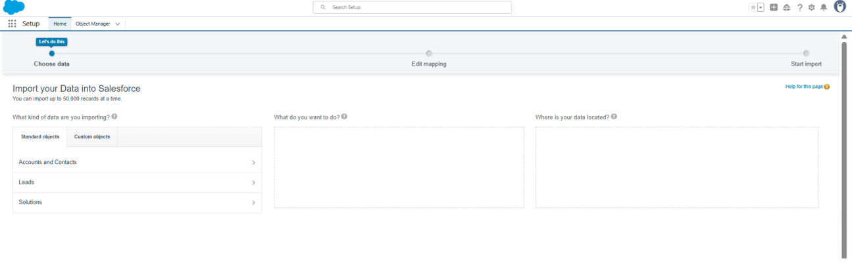

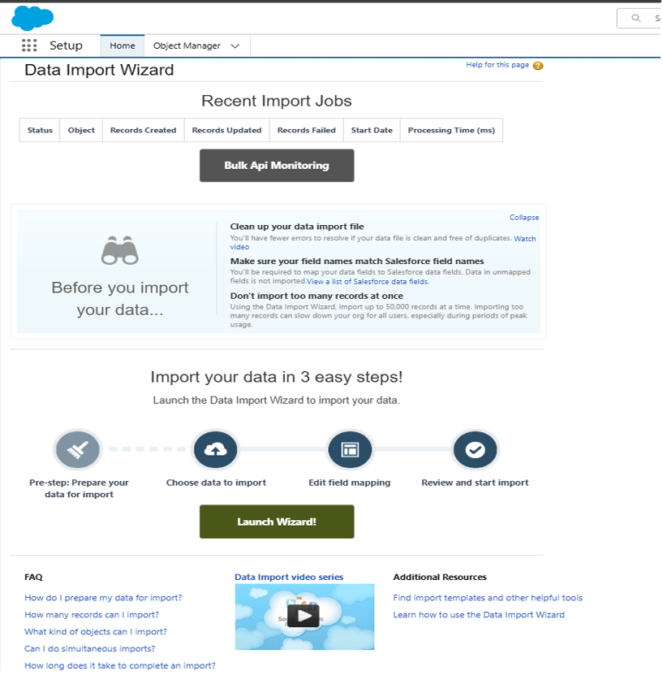

**Step 2: Manage Large Datasets with Data Loader**

* **Purpose:** For bulk data operations involving hundreds or thousands of records, such as mass imports, updates, or exports.
* **Navigation:** This is a separate client application that you must download and install.
* **Process:**
  1. Open the Data Loader application and log in to your Salesforce org.
  2. Select an operation: **Insert**, **Update**, or **Export**.
  3. Choose the **Expense__c** object and provide your CSV file.
  4. Map the fields and run the operation, reviewing the success and error logs afterward.
  5. **Why it's important:** This tool is essential for exporting data for backups or migrating large volumes of data that the UI wizard can't handle.

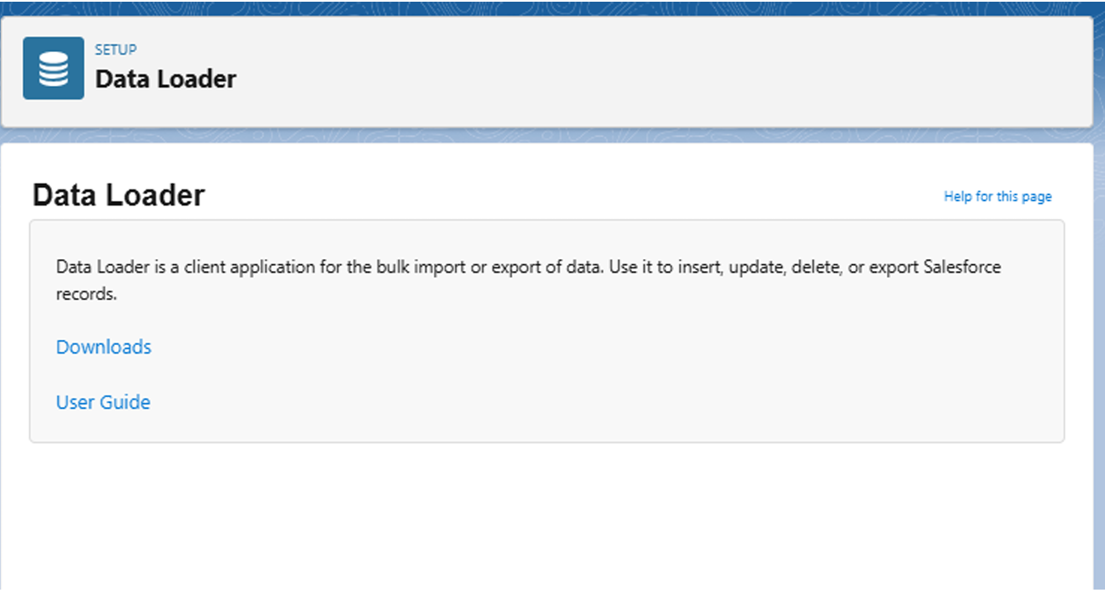

**Step 3: Prevent Duplicates with Duplicate Rules**

* **Purpose:** To maintain clean, reliable data by preventing users from creating duplicate expense records. This stops duplicate entries from appearing in reports or approval queues.
* **Navigation:** Go to **Setup** → **Duplicate Management** → **Duplicate Rules** → **New Rule**.
* **Configuration:**
  1. Select the **Expense__c** object.
  2. Name the rule (e.g., Expense_Duplicate_Check).
  3. Define the matching criteria. For example, a record is a duplicate if it has an exact match on **Amount**, **Expense Date**, and **Employee** .
  4. Set the **Action on Create** to either **Block** the user from saving or **Allow** it but show an **Alert**.
  5. **Activate** the rule.

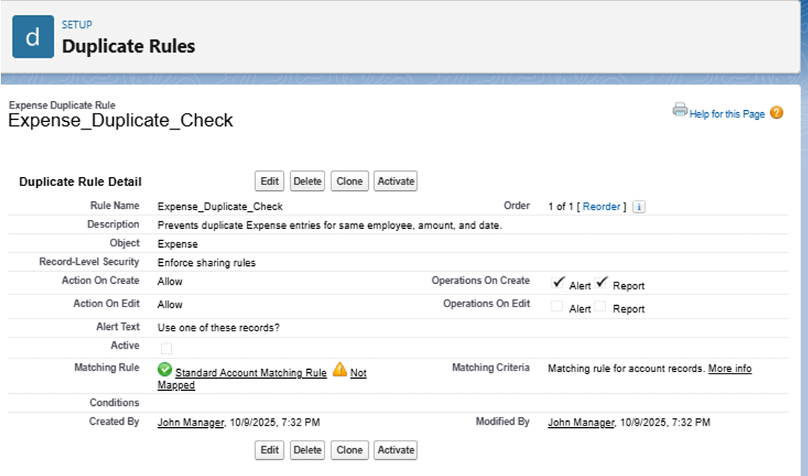

**Step 4: Schedule Regular Data Backups**

* **Purpose:** To create a secure backup of your application's data for data recovery or audit compliance. This protects against accidental data loss.
* **Navigation:** Go to **Setup** → **Data** → **Data Export**.
* **Process:**
  1. You can either **Export Now** for an immediate backup or **Schedule Export** for a recurring weekly backup.
  2. Select the objects to include, such as **Expense__c** and **User**.
  3. Start the export. Salesforce will email you a link to download a .zip file containing your data, which you should store securely.

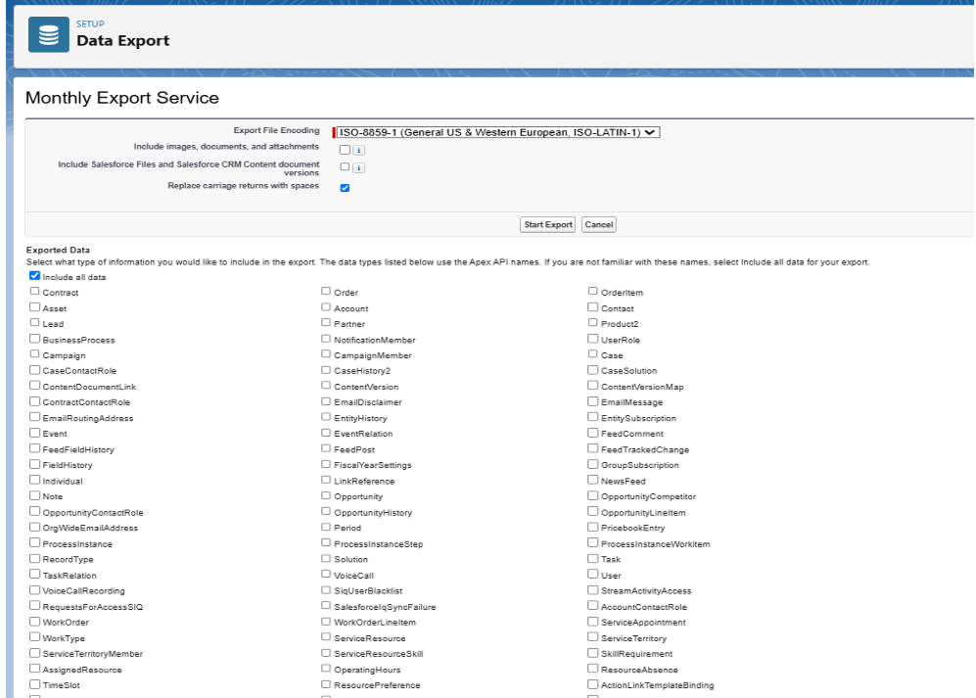

**Step 5: Deploy to Production Using Change Sets**

* **Purpose:** This is the standard, UI-based method for safely migrating all your configured components (objects, automation, code) from a Sandbox environment to the live Production org.
* **Process (In Sandbox):**
  1. Navigate to **Setup** → **Outbound Change Sets** → **New**.
  2. Name your change set (e.g., Expense_Tracker_Deployment).
  3. Click **Add** to include all your components. This includes the Expense__c custom object, all its fields, validation rules, flows, approval processes, Apex classes, and Lightning pages .
  4. Once all components are added, **Upload** the change set to your Production org.
* **Process (In Production):**
  1. Navigate to **Setup** → **Inbound Change Sets**.
  2. Find the uploaded change set, **Validate** it to check for errors, and then **Deploy** it.

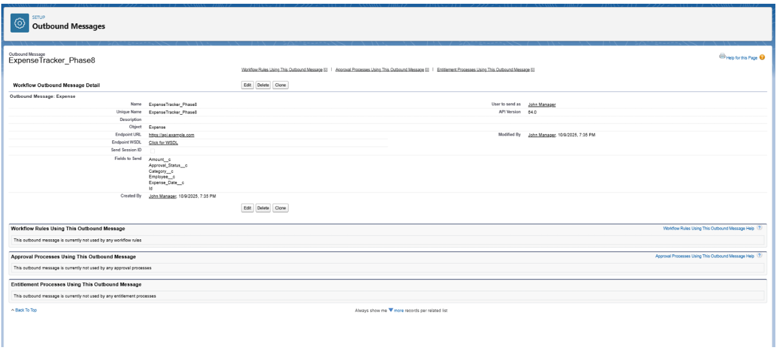

**Step 6: Advanced Deployment Options (Optional)**

For more complex or reusable applications, you can also use:

* **Packages:** You can bundle all components into a **Package** (either unmanaged or managed) using the **Package Manager**. This is ideal for distributing your app, sharing it, or for version control.
* **SFDX and VS Code:** Developers can use the **Salesforce CLI (SFDX)** and VS Code to retrieve metadata from one org (sfdx force:source:retrieve) and deploy it to another (sfdx force:source:deploy). This is a code-driven approach favored for developer-centric workflows.

